Architecture Migration

🌟 Definition
# Source: AI Source: Provided by: [Data Path: Persons Table -> ID Column: 1, Name_En Column: Motasem Essam] -> From: [ChatGPT] on [6/7/2026]
Architecture Migration is the process of changing the overall structure and design (architecture) of an application while preserving its business functionality.
Unlike platform, framework, or technology stack migration, architecture migration focuses on how application components are organized, communicate, and operate.

🎯 Purpose
# Source: AI Source: Provided by: [Data Path: Persons Table -> ID Column: 1, Name_En Column: Motasem Essam] -> From: [ChatGPT] on [6/7/2026]
Architecture migration is performed to:
- Improve scalability
- Improve maintainability
- Improve performance
- Support cloud-native development
- Increase system reliability
- Enable independent deployments
- Reduce system complexity

🧠 Simple Definition
# Source: AI Source: Provided by: [Data Path: Persons Table -> ID Column: 1, Name_En Column: Motasem Essam] -> From: [ChatGPT] on [6/7/2026]
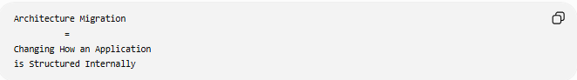
Architecture Migration
=
Changing How an Application
is Structured Internally

📚 What is Software Architecture?
# Source: AI Source: Provided by: [Data Path: Persons Table -> ID Column: 1, Name_En Column: Motasem Essam] -> From: [ChatGPT] on [6/7/2026]
Software architecture defines:
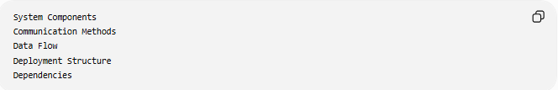
System Components
Communication Methods
Data Flow
Deployment Structure
Dependencies

Example:
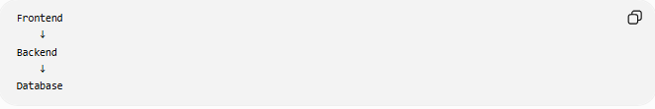
Frontend
↓
Backend
↓
Database
This is part of an application's architecture.

🔍 Common Architecture Migrations

1️⃣ Monolithic → Microservices
# Source: AI Source: Provided by: [Data Path: Persons Table -> ID Column: 1, Name_En Column: Motasem Essam] -> From: [ChatGPT] on [6/7/2026]
The most common architecture migration.
Before (Monolith)
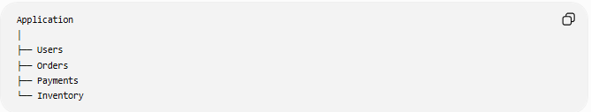
Application
│
├── Users
├── Orders
├── Payments
└── Inventory
Everything runs as one application.

After (Microservices)
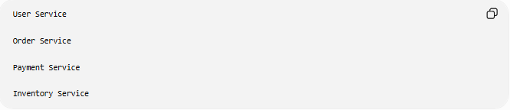
User Service

Order Service

Payment Service

Inventory Service
Each service runs independently.

Benefits:
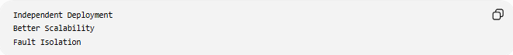
Independent Deployment
Better Scalability
Fault Isolation

2️⃣ Monolithic → Modular Monolith
# Source: AI Source: Provided by: [Data Path: Persons Table -> ID Column: 1, Name_En Column: Motasem Essam] -> From: [ChatGPT] on [6/7/2026]
A middle step before microservices.
Before
One Large Application

After
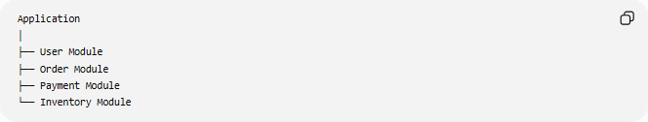
Application
│
├── User Module
├── Order Module
├── Payment Module
└── Inventory Module
Still one application but better organized.

3️⃣ Three-Tier → Cloud-Native Architecture
# Source: AI Source: Provided by: [Data Path: Persons Table -> ID Column: 1, Name_En Column: Motasem Essam] -> From: [ChatGPT] on [6/7/2026]
Before
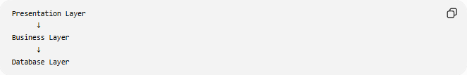
Presentation Layer
↓
Business Layer
↓
Database Layer

After
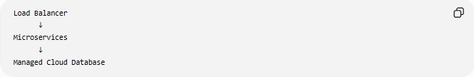
Load Balancer
↓
Microservices
↓
Managed Cloud Database

Benefits:
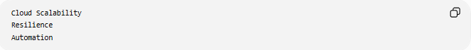
Cloud Scalability
Resilience
Automation

4️⃣ Traditional → Event-Driven Architecture
# Source: AI Source: Provided by: [Data Path: Persons Table -> ID Column: 1, Name_En Column: Motasem Essam] -> From: [ChatGPT] on [6/7/2026]
Before
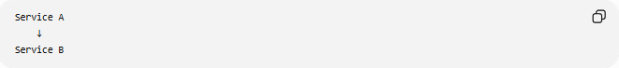
Service A
↓
Service B
Direct communication.

After
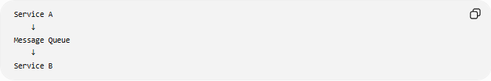
Service A
↓
Message Queue
↓
Service B

Benefits:
Loose Coupling
Asynchronous Processing

5️⃣ Traditional → Serverless Architecture
# Source: AI Source: Provided by: [Data Path: Persons Table -> ID Column: 1, Name_En Column: Motasem Essam] -> From: [ChatGPT] on [6/7/2026]
Before
Application Server

After
Serverless Functions
Examples:
- Amazon Web Services Lambda
- Microsoft Functions
- Google Cloud Functions

Benefits:
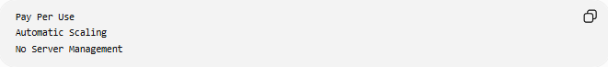
Pay Per Use
Automatic Scaling
No Server Management

🛠️ Real-World Example
# Source: AI Source: Provided by: [Data Path: Persons Table -> ID Column: 1, Name_En Column: Motasem Essam] -> From: [ChatGPT] on [6/7/2026]
Before Migration
E-Commerce System:
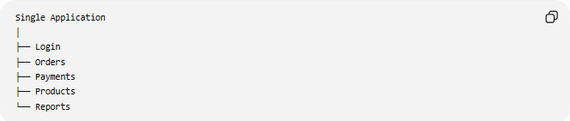
Single Application
│
├── Login
├── Orders
├── Payments
├── Products
└── Reports
Problems:
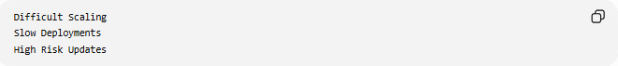
Difficult Scaling
Slow Deployments
High Risk Updates

Architecture Migration
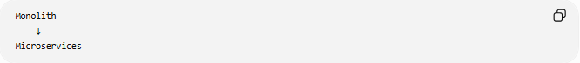
Monolith
↓
Microservices

After Migration
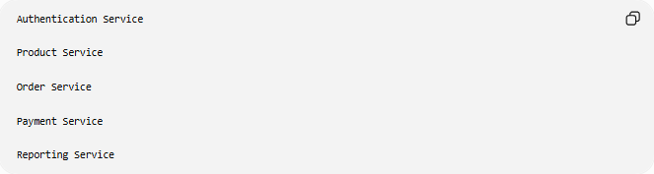
Authentication Service

Product Service

Order Service

Payment Service

Reporting Service

Benefits:
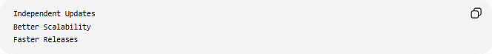
Independent Updates
Better Scalability
Faster Releases

🔄 Architecture Migration Lifecycle
# Source: AI Source: Provided by: [Data Path: Persons Table -> ID Column: 1, Name_En Column: Motasem Essam] -> From: [ChatGPT] on [6/7/2026]
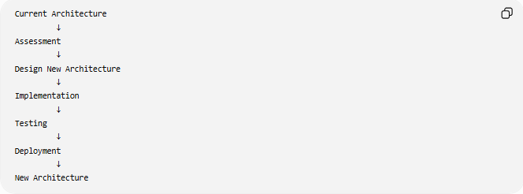
Current Architecture
↓
Assessment
↓
Design New Architecture
↓
Implementation
↓
Testing
↓
Deployment
↓
New Architecture

📦 Common Architecture Changes
# Source: AI Source: Provided by: [Data Path: Persons Table -> ID Column: 1, Name_En Column: Motasem Essam] -> From: [ChatGPT] on [6/7/2026]
Communication
Before
Direct Function Calls

After
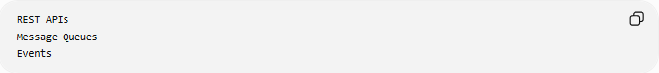
REST APIs
Message Queues
Events

Deployment
Before
Single Deployment

After
Multiple Independent Deployments

Database Strategy
Before
One Shared Database

After
Database Per Service

Scaling
Before
Scale Entire Application

After
Scale Individual Services

🌍 Common Architecture Patterns
# Source: AI Source: Provided by: [Data Path: Persons Table -> ID Column: 1, Name_En Column: Motasem Essam] -> From: [ChatGPT] on [6/7/2026]
Monolithic Architecture
One Large Application

Modular Monolith
One Application
Multiple Modules

Microservices Architecture
Many Small Services

Event-Driven Architecture
Events
Message Queues

Serverless Architecture
Functions as Services

⚠️ Common Challenges
# Source: AI Source: Provided by: [Data Path: Persons Table -> ID Column: 1, Name_En Column: Motasem Essam] -> From: [ChatGPT] on [6/7/2026]
Increased Complexity
Microservices introduce:
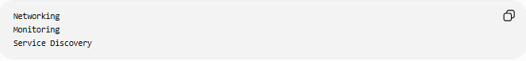
Networking
Monitoring
Service Discovery

Data Consistency
Multiple services may have separate databases.

Deployment Complexity
Managing many services can be difficult.

Cost
Migration projects may be expensive.

Team Training
Developers must learn:
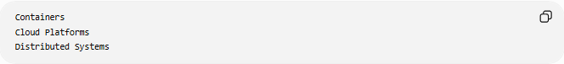
Containers
Cloud Platforms
Distributed Systems

✅ Benefits
# Source: AI Source: Provided by: [Data Path: Persons Table -> ID Column: 1, Name_En Column: Motasem Essam] -> From: [ChatGPT] on [6/7/2026]
Better Scalability
Scale Only What Is Needed

Faster Deployments
Deploy One Service
Instead of Entire System

Improved Reliability
One Service Failure
Does Not Stop Entire System

Easier Maintenance
Smaller Codebases

Cloud Readiness
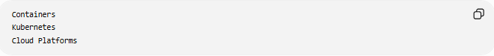
Containers
Kubernetes
Cloud Platforms

📊 Architecture Migration vs Technology Stack Migration
# Source: AI Source: Provided by: [Data Path: Persons Table -> ID Column: 1, Name_En Column: Motasem Essam] -> From: [ChatGPT] on [6/7/2026]
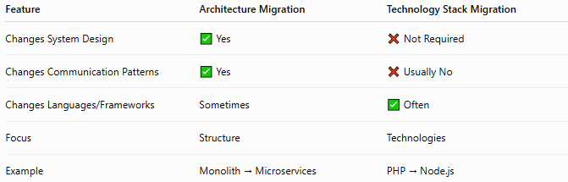
Feature | Architecture Migration | Technology Stack Migration
Changes System Design | ✅ Yes | ❌ Not Required
Changes Communication Patterns | ✅ Yes | ❌ Usually No
Changes Languages/Frameworks | Sometimes | ✅ Often
Focus | Structure | Technologies
Example | Monolith → Microservices | PHP → Node.js

Architecture Migration Example
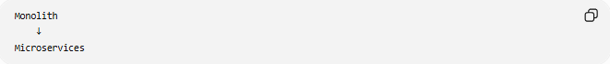
Monolith
↓
Microservices

Technology Stack Migration Example

PHP
↓
Node.js
Architecture may remain unchanged.

🛠️ Common Technologies Used
# Source: AI Source: Provided by: [Data Path: Persons Table -> ID Column: 1, Name_En Column: Motasem Essam] -> From: [ChatGPT] on [6/7/2026]
Containers
- Docker
Orchestration
- Kubernetes
Messaging
- Apache Kafka
- RabbitMQ
API Communication
- REST APIs
- GraphQL APIs

🧠 Simple Analogy
# Source: AI Source: Provided by: [Data Path: Persons Table -> ID Column: 1, Name_En Column: Motasem Essam] -> From: [ChatGPT] on [6/7/2026]
Imagine a factory.
Before
One Huge Building
All Work Inside

Migration
Split Operations
Into Specialized Buildings

After
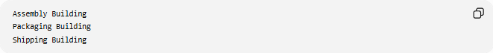
Assembly Building
Packaging Building
Shipping Building
Each building works independently but contributes to the same business.
Architecture migration works the same way:
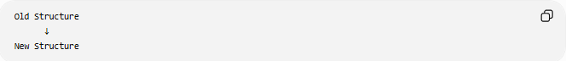
Old Structure
↓
New Structure
while keeping the application's business purpose unchanged.

🧭 Summary
# Source: AI Source: Provided by: [Data Path: Persons Table -> ID Column: 1, Name_En Column: Motasem Essam] -> From: [ChatGPT] on [6/7/2026]
Architecture Migration is a type of application migration that changes the internal structure and design of a software system. Common examples include Monolith → Microservices, Monolith → Modular Monolith, Traditional → Event-Driven, and Traditional → Serverless architectures. The goal is to improve scalability, maintainability, reliability, deployment flexibility, and cloud readiness while preserving the application's core business functionality.

